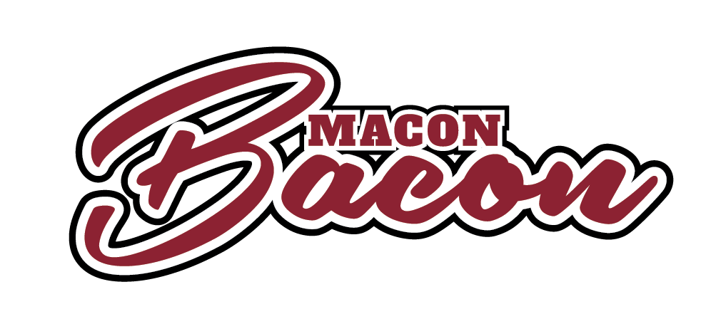
Available Positions
The Macon Bacon are hiring part-time seasonal employees to join our Coastal Plain League Organization of the Year staff. We are seeking friendly, energetic and responsible individuals to join our team focused on providing world-class service to our fans. We are hiring for the following positions:

- Guest Experience Team – Be the first point of contact for fans entering Luther Williams Field and provide customer service and hospitality and enhance their experience at the ballpark.

- Retail Team – Work in the Pork Shop (Macon Bacon team store) and various merchandise locations at the ballpark including customer transactions, restocking merchandise and providing customer service.

- Box Office/Ticket Scanner – Assist in fans purchasing or picking up tickets at Luther Williams Field as well as greeting each fan and scanning each ticket upon entry.

- Concessions – Provide fast, efficient and courteous food service to guests. Available positions include: cooks, food wrappers, cashiers, suite attendants, bartenders and waitstaff.

- Security – Ensure the safety and security of all those who attend Macon Bacon games.

- Parking – Coordinate the flow of traffic in and out of the parking lots surrounding Luther Williams Field.

- Kids Zone – Coordinate and manage the new Kids Zone area including playground, Wiffle-ball field, bounce house and batting cage.

