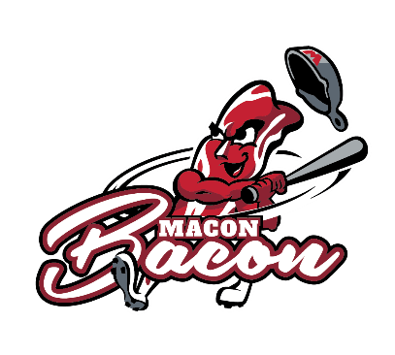
Macon Bacon 2019 Gameday Employee Questionnaire

Name: ______________________________________ Birthdate:_____________
Phone: ______________________ Email: ________________________________
**Must have working phone and email for employment**

Positions Interested: 1) _______________________________________________
2) _______________________________________________
3) _______________________________________________
Work Experience: ___________________________________________________
___________________________________________________________________
___________________________________________________________________
How did you hear about this job? ______________________________________
__________________________________________________________________
__________________________________________________________________
Circle one response for each question:
Did you work for the Macon Bacon in 2018? Yes No
Are you available nights and weekends? Yes No
Do you have reliable transportation to work? Yes No

